**Collaborative Ability Evaluation and Data Collection Plan**

**1. Collaborative Ability Evaluation Method**

**1.1 Collaborative Ability Evaluation Dimensions**

|  |  |  |  |  |
| --- | --- | --- | --- | --- |
| **Evaluation Dimension** | **Definition** | **Quantitative Metrics** | **Data Sources** | **Collection Method** |
| **Task Contribution** | Frequency of students taking initiative to assign or assume specific roles | 1. Task Allocation Ratio (%) 2. Task Completion Timeliness (%) 3. Key Outcome Relevance (%) | Group Task Allocation Table, Project Deliverables (e.g., documents/code), Peer Evaluation Files | Students fill out allocation table, submit project reports at each stage |
| **Communication Engagement** | Efficiency in proposing suggestions, resolving disagreements, and driving group decisions | 1. Effective Speaking Frequency (times/stage) 2. Active Questioning Frequency (times/stage) | Online Collaboration Platform Logs, Meeting Summaries | Manual upload of platform logs |
| **Conflict Resolution Ability** | Performance in resolving conflicts and coordinating differing opinions, measured through conflict records and resolution outcomes | 1. Conflict Negotiation Frequency (times/stage) 2. Solution Adoption Rate (%) | Online Collaboration Platform Logs, Meeting Summaries, Teacher Observation Notes | Students submit meeting summaries, teachers provide brief evaluations |
| **Team Coordination Ability** | Behavior of completing assigned tasks on time and proactively helping peers solve problems | 1. Role Switching Frequency (times/task) 2. Task Dependency Coordination Success Rate (%) | Online Collaboration Platform Logs, Meeting Summaries, Task Management Tools | Manual upload of platform logs |

**1.2 Core File Collection List**

|  |  |  |  |
| --- | --- | --- | --- |
| **File Type** | **Specific Format** | **Collection Method** | **Data Processing Purpose** |
| **1. Initial Group Task Allocation Table** | Electronic spreadsheet (Excel/Google Sheets) or structured text, including: - Task allocation - Responsible person and assistants - Planned deadline | Group leader submits to course platform or designated email | Calculate Task Allocation Ratio, Task Completion Timeliness |
| **2. Individual Submission Files** | - Individual reports (PDF/DOCX) - Code/design files (GitHub links) | Upload via course system or code repository synchronization | Analyze Individual Contribution and Team Outcome Relevance |
| **3. Periodic Group Reports** | - Mid-term report (PPT/PDF) - Final presentation materials - Meeting minutes (DOCX) | Submit to system in stages as required by the course | Track Project Progress Consistency, Problem-Solving Trajectory |
| **4. Teacher Evaluation Files** | - Evaluation form (including task completion, collaboration ability, etc.) - Written comments (for team and individuals) | Teachers input via system or upload documents | Provide Human Validation Baseline for AI model training and result calibration |
| **5. Group Communication Records** | - Online discussion logs - Meeting summaries | Students submit manually or system automatically captures (e.g., via collaboration tool APIs) | Calculate Effective Communication Frequency, Conflict Resolution Efficiency |

**2. Data Collection Process Design**

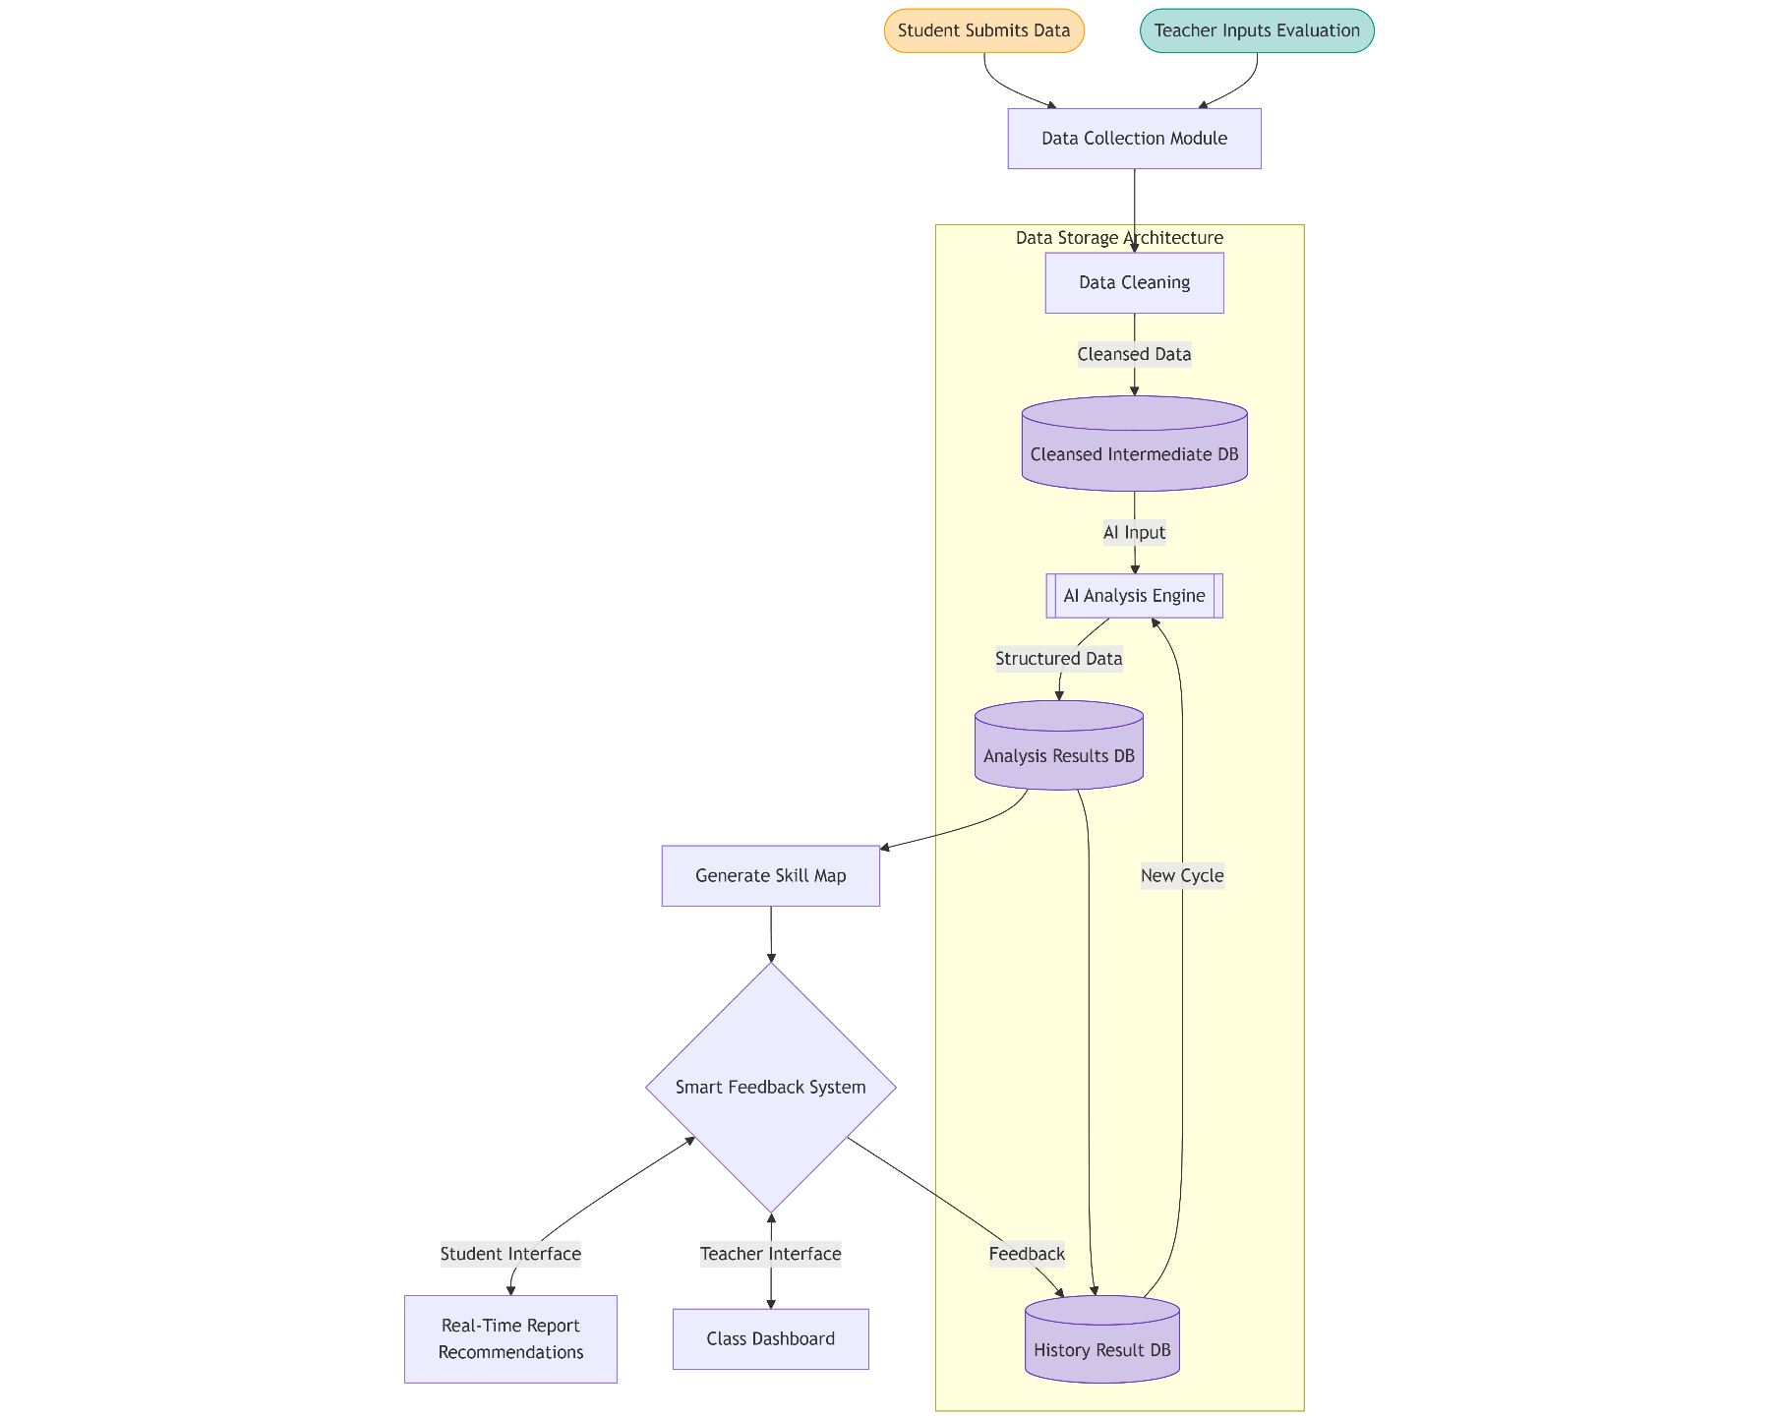

**3. Data Table Design**

**3.1 Group Task Allocation Table (Filled by Students)**

|  |  |  |  |  |  |  |
| --- | --- | --- | --- | --- | --- | --- |
| **Task Name** | **Responsible Person** | **Assistants** | **Planned Start Time** | **Planned Deadline** | **Actual Completion Time** | **Remarks** |
| Requirements Analysis | Zhang San | Li Si | 2023-10-01 | 2023-10-05 | 2023-10-05 | Completed prototype design |
| Code Development | Li Si | Wang Wu | 2023-10-06 | 2023-10-12 | 2023-10-11 | Core modules tested |

**3.2 Peer Evaluation Form**

|  |  |  |  |  |  |
| --- | --- | --- | --- | --- | --- |
| **Evaluation Item** | **Evaluation Criteria (1-5)** | **Student A Score** | **Student B Score** | **Student C Score** | **Written Feedback (Anonymous)** |
| **Communication Ability** | Actively shares information and expresses ideas clearly | 4 | 5 | 3 | "Strong coding skills but slow feedback" |
| **Collaboration Attitude** | Respects others' opinions and actively participates | 5 | 4 | 2 | "Communicates actively but occasionally off-topic" |
| **Responsibility** | Completes tasks on time and takes initiative | 3 | 5 | 4 | - |

**Data Processing**:

**Peer Score** = (Total score - Lowest score - Highest score) / (Number of evaluators - 2) * (Exclude outliers)*

**3.3 Teacher Evaluation Form**

**3.3.1 Periodic Evaluation Form**

|  |  |  |  |  |  |  |
| --- | --- | --- | --- | --- | --- | --- |
| **Evaluation Type** | **Evaluation Item** | **Group Score (1-5)** | **Zhang San** | **Li Si** | **Wang Wu** | **Comments** |
| **Group Overall** | Requirements Completeness | 4 | - | - | - | Covers core scenarios but lacks edge cases |
| **Individual Evaluation** | Logical Rigor | - | 5 | 4 | 3 | Zhang San's document structure is clear |
| **Individual Evaluation** | Collaboration Contribution | - | 3 | 5 | 2 | Li Si actively coordinates disagreements |

**3.3.2 Group Overall Evaluation Form**

|  |  |  |  |  |  |  |
| --- | --- | --- | --- | --- | --- | --- |
| **Evaluation Type** | **Evaluation Item** | **Group Score (1-5)** | **Zhang San** | **Li Si** | **Wang Wu** | **Comments** |
| **Group Overall** | Requirements Completeness | 4 | - | - | - | Covers core scenarios but lacks edge cases |
| **Individual Evaluation** | Logical Rigor | - | 5 | 4 | 3 | Zhang San's document structure is clear |
| **Individual Evaluation** | Collaboration Contribution | - | 3 | 5 | 2 | Li Si actively coordinates disagreements |

**4. Group Discussion Record Table**

**4.1 Meeting Summary**

|  |  |  |  |  |
| --- | --- | --- | --- | --- |
| **Discussion Time** | **Participants** | **Discussion Topic** | **Key Decisions** | **Follow-up Tasks** |
| 2023-10-03 14:00 | Zhang San, Li Si, Wang Wu | Requirement Prioritization | Complete MVP version first | Zhang San revises requirement documentation |
| 2023-10-10 10:30 | Li Si, Wang Wu | Test Case Design | Add 30% test cases via manual testing | Li Si develops test scripts |

**4.2 Speaking Records Details (Per Meeting)**

|  |  |  |  |  |
| --- | --- | --- | --- | --- |
| **Discussion Topic** | **Speaker** | **Number of Speeches** | **Total Speaking Duration** | **Key Points Summary** |
| Requirement Prioritization | Zhang San | 2 | 5 minutes | Prioritize core functionality development |
| Requirement Prioritization | Li Si | 3 | 8 minutes | Emphasize test coverage |
| Requirement Prioritization | Wang Wu | 1 | 2 minutes | Support Zhang San's proposal |

(As an alternative, read the group discussion chat logs directly for data analysis.)